Beverage Delivery App-
User Opens app-
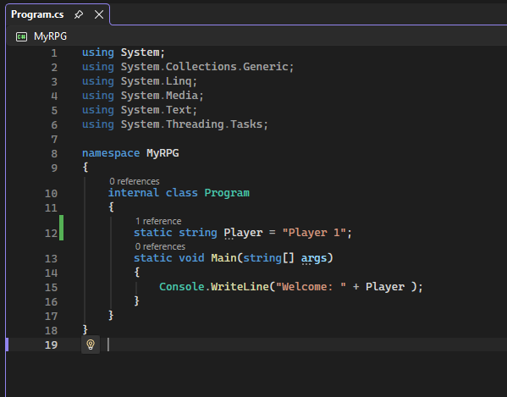

<ButtonContent=”ClickMe”
Click=”Button Click”/>

